Chapter 2 Geometry
Worksheet A

1 Find the value of x in each of the following, giving reasons.

a 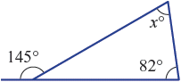 b 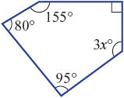

__________________________ __________________________

__________________________ __________________________

__________________________ __________________________

c 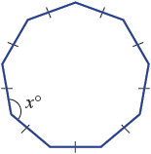 d 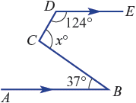

__________________________ __________________________

__________________________ __________________________

__________________________ __________________________

2 In this diagram AC = DC and BC = EC.
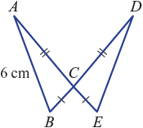
a Prove ΔABC ≡ ΔDEC.

___________________________________________________

___________________________________________________

b Prove AB = DE.

___________________________________________________

___________________________________________________

c State the length DE.

___________________________________________________

3 Complete these steps to prove that a parallelogram (with opposite sides parallel) has equal opposite angles.
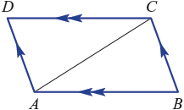
a Prove ΔABC ≡ ΔCDA.

______________________________________________________________________

______________________________________________________________________

______________________________________________________________________

b Hence prove ∠ABC = ∠CDA.

______________________________________________________________________

______________________________________________________________________

______________________________________________________________________

4 These two shapes are similar.
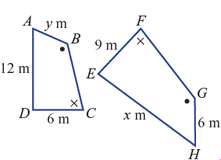
a Write a similarity statement for the two shapes.

______________________________________________________________________

b Find the scale factor.

______________________________________________________________________

c Find the value of x.

______________________________________________________________________

d Find the value of y.

______________________________________________________________________

5 Consider the following diagram.
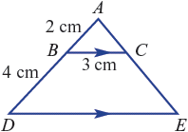

a Prove ΔABC ||| ΔADE.

______________________________________________________________________

______________________________________________________________________

______________________________________________________________________

b Find the length DE.

______________________________________________________________________

______________________________________________________________________

